**Dok 4.4.1**

**Exam For**

**Senior .NET Programmer Candidate**

**Lembaga Penjamin Simpanan 2023**

**Group Sistem Informasi**

File ini beserta isi dan format-nya adalah milik Lembaga Penjamin Simpanan (LPS). Tidak diperkenankan untuk didistribusikan, digandakan dan atau dipergunakan sebagian ataupun seluruhnya dalam bentuk apapun tanpa seijin LPS secara tertulis terlebih dahulu kecuali untuk kepentingan pelaksanaan pekerjaan ini.

# Verification Sheet

|  |  |  |
| --- | --- | --- |
| **Role** | **Name** | **Signature** |
| Candidate | Allfian Nugraha |  |
| Assessor |  |  |

**Exam for Senior .NET Programmer Candidate Halaman 1/15**

# Querying Microsoft SQL Server 2012

This exam measures your ability to accomplish the technical tasks listed below:

* 1. Create Database Objects
  2. Work with Data
  3. Modify Data
  4. Troubleshoot & Optimize

This exam is intended for SQL Server database administrators, system engineers, and developers with two or more years of experience, who are seeking to validate their skills and knowledge in writing queries.

## Questions:

1. You develop a Microsoft SQL Server 2012 database that contains a table named Products. The Products table has the following definition:

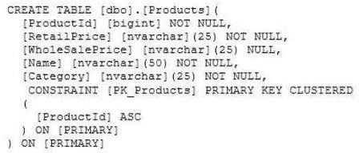

You need to create an audit record only when either the RetailPrice or WholeSalePrice column is updated. Which Transact-SQL query should you use?

1. ~~CREATE TRIGGER TrgPriceChange ON Products FOR UPDATE AS IF COLUMNS_CHANGED(RetailPrice, WholesalePrice)~~

* ~~- Create Audit Records~~

1. ~~CREATE TRIGGER TrgPriceChange ON Products FOR UPDATE AS IF EXISTS(SELECT RetailPrice from inserted) OR~~

~~EXISTS (SELECT WholeSalePnce FROM inserted)~~

* ~~- Create Audit Records~~

1. ~~CREATE TRIGGER TrgPriceChange ON Products FOR UPDATE AS IF COLUMNS_UPDATED(RetailPrice, WholesalePrice)~~

* ~~- Create Audit Records~~

1. CREATE TRIGGER TrgPriceChange ON Products FOR UPDATE AS IF UPDATE(RetailPrice) OR UPDATE(WholeSalePrice)

* - Create Audit Records

1. A table named Profits stores the total profit made each year within a territory. The Profits table has columns named Territory, Year, and Profit. You need to create a report that displays the profits made by each territory for each year and its previous year. Which Transact-SQL query should you use?
   1. SELECT Territory, Year, Profit,

LEAD(Profit, 1, 0) OVER (PARTITION BY Territory ORDER BY Year) AS PrevProfit FROM Profits

* 1. ~~SELECT Territory, Year, Profit,~~

~~LAG(Profit, 1, 0) OVER (PARTITION BY Year ORDER BY Territory) AS PrevProfit FROM Profits~~

* 1. ~~SELECT Territory, Year, Profit,~~

~~LAG(Profit, 1, 0) OVER (PARTITION BY Territory ORDER BY Year) AS PrevProfit FROM Profits~~

* 1. ~~SELECT Territory, Year, Profit,~~

~~LEAD(Profit, 1, 0) OVER (PARTITION BY Year ORDER BY Territory) AS PrevProfit FROM Profits~~

1. You use Microsoft SQL Server 2012 database to develop a shopping cart application. You need to rotate the unique values of the ProductName field of a table-valued expression into multiple columns in the output. Which Transact-SQL operator should you use?
   1. ~~CROSS JOIN~~
   2. ~~CROSS APPLY~~
   3. PIVOT
   4. ~~UNPIVOT~~
2. You administer a Microsoft SQL Server database that supports a shopping application.

You need to retrieve a list of customers who live in territories that do not have a sales person. Which Transact- SQL query or queries should you use? (Each correct answer presents a complete solution. Choose all that apply.)

* 1. ~~SELECT CustomerID FROM Customer~~

~~WHERE TerritoryID <>SOME(SELECT TerritoryID FROM Salesperson)~~

* 1. ~~SELECT CustomerID FROM Customer~~

~~WHERE TerritoryID <>ALL(SELECT TerritoryID FROM Salesperson)~~

* 1. ~~SELECT CustomerID FROM Customer~~

~~WHERE TerritoryID <>ANY(SELECT TerritoryID FROM Salesperson)~~

* 1. SELECT CustomerID FROM Customer

WHERE TerritoryID NOT IN(SELECT TerritoryID FROM Salesperson)

1. You are developing a database that will contain price information. You need to store the prices that include a fixed precision and a scale of six digits. Which data type should you use?
   1. ~~Float~~
   2. ~~Money~~
   3. ~~Smallmoney~~
   4. Numeric
2. You develop three Microsoft SQL Server 2012 databases named Database1, Database2, and Database3. You have permissions on both Database1 and Database2. You plan to write and deploy a stored procedure named dbo.usp_InsertEvent in Database3. dbo.usp_InsertEvent must execute other stored procedures in the other databases. You need to ensure that callers that do not have permissions on Database1 or Database2 can execute the stored procedure.

Which Transact-SQL statement should you use?

* 1. ~~USE Database2~~
  2. ~~EXECUTE AS OWNER~~
  3. ~~USE Database1~~
  4. EXECUTE AS CALLER

1. You administer a Microsoft SQL Server 2012 database that has multiple tables in the Sales schema. Some users must be prevented from deleting records in any of the tables in the Sales schema. You need to manage users who are prevented from deleting records in the Sales schema. You need to achieve this goal by using the minimum amount of administrative effort. What should you do?
   1. Create a custom database role that includes the users. Deny Delete permissions on the Sales schema for the custom database role.
   2. ~~Include the Sales schema as an owned schema for the db_denydatawriter role. Add the users to the db_denydatawriter role.~~
   3. ~~Deny Delete permissions on each table in the Sales schema for each user.~~
   4. ~~Create a custom database role that includes the users. Deny Delete permissions on each table in the Sales schema for the custom database role.~~
2. You use Microsoft SQL Server 2012 to create a stored procedure as shown in the following code segment. (Line numbers are included for reference

only.)

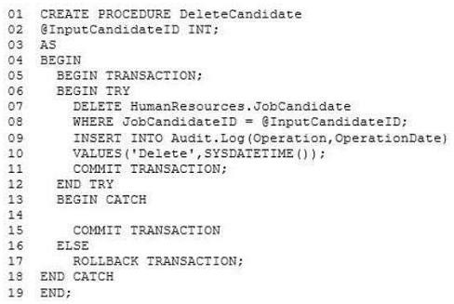

The procedure can be called within other transactions. You need to ensure that when the DELETE statement from the HumanResources.JobCandidate table succeeds, the modification is retained even if the insert into the Audit.Log table fails. Which code segment should you add to line 14?

* 1. ~~IF @@TRANCOUNT = 0~~
  2. IF (XACT_STATE ( ) ) = 0
  3. ~~IF (XACT_STATE ( ) ) = 1~~
  4. ~~IF @@TRANCOUNT = l~~

1. You have a Microsoft SQL Server 2012 database that contains tables named Customers and Orders. The tables are related by a column named CustomerID. You need to create a query that meets the following requirements:

* Returns the CustomerName for all customers and the OrderDate for any orders that they have placed.
* Results must include customers who have not placed any orders.

Which Transact-SQL query should you use?

* 1. ~~SELECT CustomerName, OrderDate FROM Customers~~

~~RIGHT OUTER JOIN Orders~~

~~ON Customers.CustomerID = Orders.CustomerID~~

* 1. ~~SELECT CustomerName, CrderDate FROM Customers~~

~~JOIN Orders~~

~~ON Customers.CustomerID = Orders.CustomerID~~

* 1. ~~SELECT CustomerName, OrderDate FROM Customers~~

~~CROSS JOIN Orders~~

~~ON Customers.CustomerID = Orders.CustomerID~~

* 1. SELECT CustomerName, OrderDate FROM Customers

LEFT OUTER JOIN Orders

ON Customers.CustomerID = Orders.CustomerID

1. Your database contains a table named SalesOrders. The table includes a DATETIME column named OrderTime that stores the date and time each order is placed. There is a non-clustered index on the OrderTime column. The business team wants a report that displays the total number of orders placed on the current day. You need to write a query that will return the correct results in the most efficient manner.

Which Transact-SQL query should you use?

* 1. ~~SELECT COUNT(*) FROM SalesOrders~~

~~WHERE OrderTime = CONVERT(DATE, GETDATE())~~

* 1. ~~SELECT COUNT(*) FROM SalesOrders WHERE OrderTime = GETDATE()~~
  2. ~~SELECT COUNT(*) FROM SalesOrders~~

~~WHERE CONVERT(VARCHAR, OrderTime, 112) = CONVERT(VARCHAR, GETDATE(I, 112))~~

* 1. SELECT COUNT(*) FROM SalesOrders

WHERE OrderTime >= CONVERT(DATE, GETDATE())

AND OrderTime <DATEADD(DAY, 1, CONVERT(DATE, GETDATE()))

# Programming in C#

Candidates for this exam are developers with experience in programming essential business logic for a variety of application types, hardware, and software platforms using C#.

Candidates should also have a thorough understanding of the following:

* 1. Managing program flow and events
  2. Asynchronous programming and threading
  3. Data validation and working with data collections including LINQ
  4. Handling errors and exceptions
  5. Working with arrays and collections
  6. Working with variables, operators, and expressions
  7. Working with classes and methods
  8. Decision and iteration statements

## Questions:

1. You have a collection of Order objects.The collection must meet the following requirements:
   * Use strongly typed members.
   * Process Order objects in first-in-first-out order.
   * Store values for each Order object.
   * Use zero-based indices.

You need to use a collection type that meets the requirements.Which collection type should you use?

1. Queue<T>
2. ~~SortedList~~
3. ~~LinkedList<T>~~
4. ~~HashTable~~
5. ~~Array<T>~~
6. You are developing an application that includes the following code segment. (Line numbers are included for reference only.)

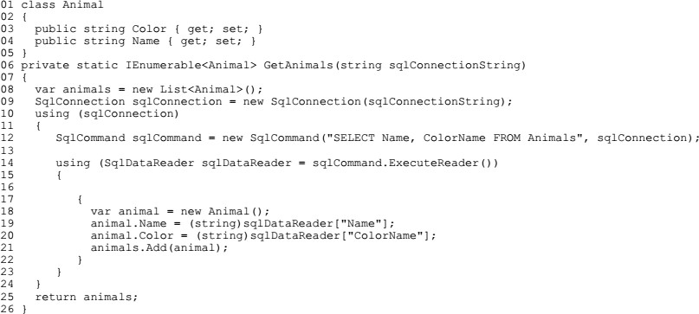

The GetAnimals() method must meet the following requirements:

* Connect to a Microsoft SQL Server database.
* Create Animal objects and populate them with data from the database.
* Return a sequence of populated Animal objects.

You need to meet the requirements. Which two actions should you perform? (Each correct answer presents part of the solution. Choose two.)

1. ~~Insert the following code segment at line 16: while(sqlDataReader.NextResult())~~
2. Insert the following code segment at line 13: sqlConnection.Open();
3. ~~Insert the following code segment at line 13: sqlConnection.BeginTransaction();~~
4. ~~Insert the following code segment at line 16: while(sqlDataReader.Read())~~
5. ~~Insert the following code segment at line 16: while(sqlDataReader.GetValues())~~
6. You are developing an application that uses the Microsoft ADO.NET Entity Framework to retrieve order information from a Microsoft SQL Server

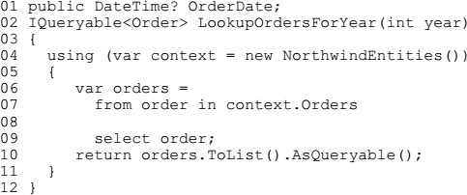database. The application includes the following code. (Line numbers are included for reference only.)

The application must meet the following requirements:

* return only orders that have an OrderDate value other than null.
* return only orders that were placed in the year specified by the method year parameter
* not raise an exception

You need to ensure that the application meets the requirements. Which code segment should you insert at line 08?

1. ~~where order.OrderDate.Value != null && order.OrderDate.Value.Year >= year~~
2. ~~where order.OrderDate.Value == null && order.OrderDate.Value.Year == year~~
3. where order.OrderDate.HasValue && order.OrderDate.Value.Year >= year
4. ~~where order.OrderDate.Value.Year == year~~
5. You are developing an application. The application includes a method named ReadFile that reads data from a file. The ReadFile() method must

meet the following requirements:

* it must not make changes to the data file.
* It must allow other processes to access the data file.
* It must not throw an exception if the application attempts to open a data file that does not exist.

You need to implement the ReadFile method. Which code segment should you use?

1. ~~var fs = File.Open(Filename, FileMode.OpenOrCreate, FileAccess.Read, FileShare.ReadWrite);~~
2. var fs = File.Open(Filename, FileMode.Open, FileAccess.Read, FileShare.ReadWrite);
3. ~~var fs = File.Open(Filename, FileMode.OpenOrCreate, FileAccess.Read, FileShare.Write);~~
4. ~~var fs = File.ReadAllLines(Filename);~~
5. ~~var fs = File.ReadAllBytes(Filename);~~
6. An application receives JSON data in the following format:



The application includes the following code segment. (Line numbers are included for reference only.)

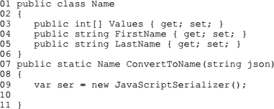

You need to ensure that the ConvertToName() method returns the JSON input string as a Name object. Which code segment should you insert at line 10?

1. ~~return ser.ConvertToType<Name>(json);~~
2. ~~return ser.DeserializeObject(json);~~
3. return ser.Deserialize<Name>(json) ;
4. ~~return (Name)ser.Serialize(json);~~
5. An application includes a class named Person. The Person class includes a method named GetData. You need to ensure that the GetData() method can be used only by the Person class or a class derived from the Person class. Which access modifier should you use for the GetData() method?
6. ~~internal~~
7. protected
8. ~~protected internal~~
9. ~~private~~
10. ~~Public~~
11. You are creating an application that manages information about zoo animals. The application includes a class named Animal and a method named Save. The Save() method must be strongly typed. It must allow only types inherited from the Animal class that uses a constructor that accepts no parameters. You need to implement the Save() method. Which code segment should you use?

C.

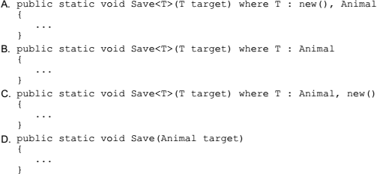

1. You are developing an application by using C#. The application includes an object that performs a long running process. You need to ensure that the garbage collector does not release the object's resources until the process completes. Which garbage collector method should you use?
2. ~~ReRegisterForFinalize()~~
3. SuppressFinalize()
4. ~~Collect()~~
5. ~~WaitForFullGCApproach()~~
6. You are implementing a method named Calculate that performs conversions between value types and reference types. The following code segment implements the method. (Line numbers are included for reference only.)

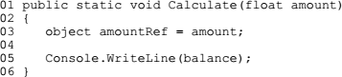

You need to ensure that the application does not throw exceptions on invalid conversions. Which code segment should you insert at line 04?

1. ~~int balance = (int)(float)amountRef;~~
2. int balance = (int)amountRef;
3. ~~int balance = amountRef;~~
4. ~~int balance = (int) (double) amountRef;~~
5. You are developing an application that produces an executable named MyApp.exe and an assembly named MyApp.dll. The application will be sold to several customers.

You need to ensure that enough debugging information is available for MyApp.exe, so that if the application throws an error in a customer's environment, you can debug the error in your own development environment. What should you do?

1. ~~Digitally sign MyApp.dll.~~
2. Produce program database (PDB) information when you compile the code.
3. ~~Compile MyApp.exe by using the /unsafe compiler option.~~
4. ~~Initializes a new instance of the AssemblyDelaySignAttribute class in the MyApp.dll constructor.~~

# Microsoft Certified Solutions Developer: Web Applications

This exam measures your ability to accomplish the technical tasks listed below:

* 1. Design the application architecture
  2. Design the user experience (UX)
  3. Develop the user experience
  4. Troubleshoot and debug web applications
  5. Design and implement security
  6. Access data
  7. Design and implement WCF Services
  8. Deploy web applications and services

## Questions:

1. You are developing an ASP.NET MVC web application that contains the following HTML.

<table id= "customer" ></table>

You also have an ASP.NET Web API application that contains a call for retrieving customers. You must send and retrieve the data in the most compact format possible. You need to update the HTML for the customers table to contain data from the Web API application.

Which script segment should you use? A.

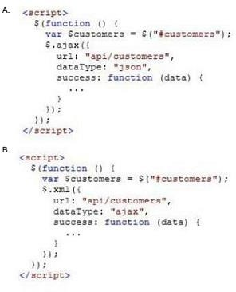

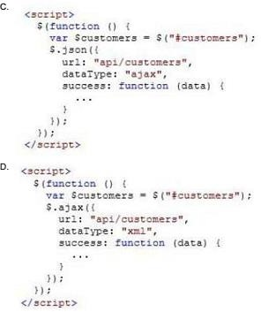

1. You are testing an ASP.NET application. The test plan requires that tests run against the application's business layer. You need to use the test project template that meets this requirement. Which template should you use?
   1. ~~Web Test Project~~
   2. ~~Load Test Project~~
   3. Unit Test Project
   4. ~~Coded Test Project~~
2. You are developing an ASP.NET MVC application by using Visual Studio 2012. The application throws and handles exceptions when it runs. You need to examine

the state of the application when exceptions are thrown. What should you do?

* 1. From the DEBUG menu in Visual Studio 2012, select Exceptions. Enable the Thrown check box for Common Language Runtime Exceptions.
  2. ~~From the DEBUG menu in Visual Studio 2012, select Exceptions. Disable the User-unhandled check box for Common Language Runtime Exceptions.~~
  3. ~~Add the following code to the Web.config file of the application:~~

~~<customErrors mode="On">~~

~~<error statusCode="500" redirect="CustomErrors.html" />~~

~~</customErrors>~~

* 1. ~~Add the following code to the Web.config file of the application:~~

~~<customErrors mode="On" >~~

~~<error statusCode="404" redirect="CustomErrors.html"/>~~

~~</customErrors>~~

1. You are developing an ASP.NET MVC news aggregation application that will be deployed to servers on multiple networks. The application must be compatible with multiple browsers. A user can search the website for news articles. You must track the page number that the user is viewing in search results. You need to program the location for storing state information about the user's search. What should you do?
   1. ~~Store search results and page index in Session.~~
   2. ~~Use Application state to store search terms and page index.~~
   3. Use QueryString to store search terms and page index.
   4. ~~Store search results and page index in TempData~~
2. You are developing an ASP.NET MVC application. The application is deployed in a web farm and is accessed by many users. The application must handle web server failures gracefully. The servers in the farm must share the state information. You need to persist the application state during the session. What should you

implement?

* 1. A state server
  2. ~~Cookieless sessions~~
  3. ~~A web garden on the web servers~~
  4. ~~An InProc session~~

1. You are developing an ASP.NET MVC application that displays stock market information. The stock market information updates frequently and must be displayed

in real-time. You need to eliminate unnecessary header data, minimize latency, and transmit data over a full-duplex connection. What should you do?

* 1. ~~Implement long-running HTTP requests.~~
  2. ~~Instantiate a MessageChannel object on the client.~~
  3. Implement WebSockets protocol on the client and the server.
  4. ~~Configure polling from the browser~~

1. You are developing an ASP.NET MVC application. The application must allow users to enter JavaScript in a feedback text box only. You need to disable request

validation. What should you do?

* 1. ~~Apply and set the CausesClientSideValidation attribute on the text box to FALSE.~~
  2. ~~Apply and set the ValidateInput attribute on the text box to FALSE.~~
  3. Use the HttpRequest.Unvalidated property to read the unvalidated form value.
  4. ~~Use the HttpRequest.Form property to read the unvalidated form value.~~

1. You are developing an ASP.NET MVC application that will be deployed on a web farm.

Passwords must be stored in the web.config file and must not be readable

or in a format that is easily decodable You need to encrypt the passwords that are stored in the web.config file. Which command-line tool should you use?

* 1. Aspnet_regiis.exe
  2. ~~Ngen.exe~~
  3. ~~Aspnet_merge.exe~~
  4. ~~EdmGen.exe~~

1. You are designing a distributed application. The application must store a small amount of insecure global information that does not change frequently. You need to

configure the application to meet the requirements. Which server-side state management option should you use? (Each correct answer presents a complete

solution. Choose all that apply.)

* 1. Application state
  2. ~~Session state~~
  3. ~~Database support~~
  4. ~~Profile properties~~

1. You are designing an ASP.NET Web API application. You need to select an HTTP verb to allow blog administrators to moderate a comment. Which HTTP verb

should you use?

* 1. ~~GET~~
  2. ~~POST~~
  3. DELETE
  4. ~~PUT~~

- Thank You -